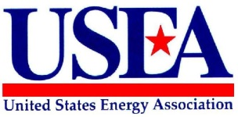

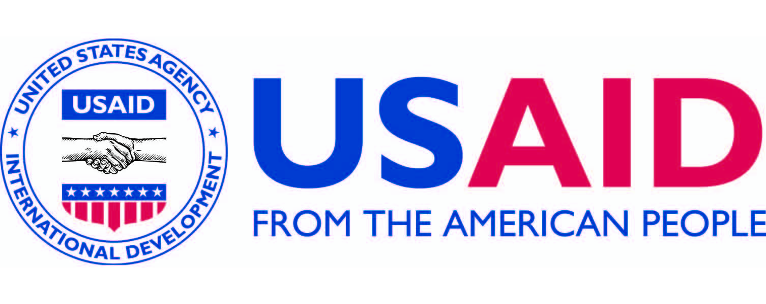

United States Energy Association
Request for Proposal: Preparing for DER Training

REQUEST FOR PROPOSAL – Preparing the Government of Colombia for Distributed Energy Resources (DER) Expansion

Closing date of RFP: August 29, 2018

Implementing Agency: United States Energy Association

Funding Agency: United States Agency for International Development

The United States Energy Association (USEA) is inviting prospective organizations or individuals through this Request for Proposal (RFP) to submit proposals for conducting a training program on “Preparing the GOC for DER Expansion” for XM, Colombia’s System Operator; UPME, the energy planning agency; the Ministry of Mines and Energy; CREG, the Regulatory Board, and other electricity-sector organizations. This is an activity implemented by USEA under the United States Agency for International Development (USAID) Energy Utility Partnership Program (EUPP).

Proposals are due by 17:00 hours EST of the closing date. Please forward your proposal in soft copy (PDF form) to Ms. Johanna Koolemans-Beynen, Senior Program Coordinator, at jkoolemans-beynen@usea.org.

As this is a USAID-funded program, the RFP follows USAID Procurement Regulations and Laws. All bidder details will be kept confidential.

- INTRODUCTION

The U.S. Energy Association (USEA) is an association of public and private energy-related organizations, corporations, and government agencies.

Through a cooperative agreement with the USAID Bureau for Economic Growth, Education and Environment (E3), USEA implements the Energy Utility Partnership Program (EUPP), available to all USAID-assisted countries and USAID Missions. EUPP supports the efforts in USAID-assisted developing countries to increase environmentally sustainable energy production and to improve the operational efficiency and increased financial viability of their utilities and related institutions, with the goal of increasing the access of these countries to safe, reliable, affordable and environmentally sound energy services.

USEA conducts a number of activities under the EUPP mechanism for USAID Colombia. These activities are focused on supporting the Colombian Government’s efforts to incorporate renewables onto its electricity grid. USAID Colombia has supported Colombia’s efforts to overhaul its grid code, to expand energy auctions to encompass renewables, to examine the possibility of setting up real-time markets, to begin using meteorological forecasts to improve estimates of renewable energy production, and to prepare regulations for smart metering infrastructure, among other activities.

- BACKGROUND
While Colombia’s electricity grid is currently low in emissions since it is mainly hydroelectric, it is projected to lose as much as 20 percent of its clean energy generation due to expected increases in the number of El Niño drought years. In order to offset this decrease, Colombia is looking to increase production from solar and wind resources, as expressed in the National Development Plan 2014-2018, which outlines plans to increase wind generation from around 20 MW currently to about 1.5 GW by 2023, and solar from around 70 MW currently to around 700 MW by 2023. It is expected that an important amount of the expected increase in renewables will come from Distributed Energy Resources (DER), mainly rooftop solar, due to high solar energy potential, and favorable regulations. However, DERs present significant challenges to grid operations, and to system operators in particular, due to the intermittent nature of DERs combined with a lack of visibility, since they are located on the load side of the grid. Depending on regulations, system operators may not have a clear idea of the amount of DER on their system, making it extremely difficult to model their probable behavior under different meteorological conditions.

Between 30 and 40 high level professionals from key energy entities of the Colombian government will attend the training, including 3-4 participants from each of the following entities:
- XM, Compañía de Expertos en Mercados, which operates and administers Colombia's electricity market, manages financial transactions in the electricity and gas wholesale markets and administers financial derivatives markets and the underlying assets of electrical energy or gas companies, including compensation systems.
- UPME, la Unidad de Planeación Minero-Energética, which plans the development of the energy sector in an integral, indicative, permanent and coordinated way, with the public and private agents of the energy sector, ensuring the sustainable development and use of Colombia’s energy resources; they produce and disseminate the information required for policy formulation and investment decision making, and support the Ministry of Mines and Energy in achieving its objectives and goals.
- The Ministry of Mines and Energy, in charge of developing national electricity policy, manages key energy programs and leads the development of the sector.
- CREG, la Comisión de Regulación de Energía y Gas, develops national energy regulations. They are an eminently technical entity whose objective is to ensure that the services of electric power, natural gas, liquefied petroleum gas (LPG) and liquid fuels are provided to as many people as possible, at the lowest possible cost to users and with adequate remuneration so that companies can guarantee quality, coverage and expansion.

- SCOPE OF WORK

Duties and Responsibilities

The training is to consist of a single five (5) day DER preparation training course in late October or early November 2018 for thirty (30) mid- and senior-level personnel from the above-mentioned electricity-sector organizations, to take place in or near Bogota, Colombia.

The training program should focus on the aspects of DER integration issues that are relevant for an ISO, from the system operator’s prospective. The proposal should include the following topics:

- Overview of DER
- DER in front of and behind the meter
- What resources are included in DER vs DG
- Policy and regulatory issues
- DER rate structures

- Integration of DER into the electricity markets
- DER management systems
- Business models
- Interaction requirements between ISO, DSO and DER aggregators at high penetration levels of DER
- DER measurement, evaluation, and verification
- DER supply and demand in the electricity markets
- Examples of current DR programs in North-American wholesale markets DER integration and DER providers
- Outlook of DER integration (in front and behind the meter) and the future role of ISO´s

- Planning the bulk power system for high DER penetrations
- Introduction to planning for high DER penetrations
- Load forecasting in different time horizons, from long term to real time, with DERs
- Hosting capacity (feeder and system level)
- Impact of DERs on bulk power system reliability and stability
- Special considerations regarding impact of behind the meter DER on system reliability
- Load flow and dynamic studies for assessing the impact of DER on the bulk power system
- Modelling DER and use of the simulation models to assess the reliability of DERs on bulk power system reliability

- DER Interconnection standards
- The importance of interconnection standards
- IEEE 1547 standard: Focusing on aspects relevant for the bulk power system operator
- International experience and standards

- Power system operations with high DER penetration
- Approaches for incorporating DER forecasting into generation scheduling and dispatch for real time, intraday and day ahead time horizons
- Impact of DER on operational reserves
- Approaches and best practices for improving ISO control center’s monitoring and control of DERs
- Options for managing DERs, such as use of aggregators
- Interoperability with distribution companies

- Outlook for DER
- Innovative operational practices and interactions between ISO and DSO
- Demand response
- Electric vehicles
- Energy efficiency
- Dynamic pricing
- The future role of the ISO´s in a system with large shares of DER

- Wrap up session
- Brainstorming on steps forward, application of course to needs of the participants

At the end of the course, the participants should be able to demonstrate solid understanding of main concepts of DER, as well as methods for implementing best practices for integrating DERs.

The training course will include pre-training and post-training surveys administered to all participants. A pre-training survey will be designed to assess participants’ baseline knowledge and competencies and to identify knowledge gaps and weak areas, so that the course can be modified as necessary. A post-training/skill assessment survey will be designed to measure participating trainees’ progress. An activity to identify relevant best practices for implementing DER integration will be developed and applied on the last day of the course, and results included in the final report (below).

- Deliverables

The following deliverables are required:

- DER Training outline with contents specified in Section III;
- Pre-training and post-training surveys, and the best practices activity described above;
- Final training curriculum, including manuals and all other training materials distributed to the participants electronically;
- Conduct training program in Colombia for five (5) days;
- Final report to include the following:
- Summary of major outcomes of the training program;
- Challenges encountered and knowledge/skills acquired by participants;
- Summaries of the administered pre-training and post-training surveys;
- Results of the steps forward activity.

- Implementation and Approach

The purpose of this RFP is to solicit proposals from various candidate organizations or individuals, conduct a fair evaluation, and select the one (1) organization deemed most suitable to conduct DER training.

USEA Responsibilities

USEA will be responsible for arrangements and associated costs of a trip to Colombia. USEA will arrange and bear the costs of:

- Economy-class roundtrip airfare to Bogotá;
- Per diem (meals and lodging) for up to 7 days in Bogotá and/or at the training location (Note: Lodging to be provided according to U.S. government regulations);
- Reimbursement of visa fees (if needed);
- Reimbursement of vaccinations (if needed) and travel medication expenses;
- International health insurance for the duration of the travel to Colombia;
- Ground transportation to/from the airport;
- Local transportation;
- Training venue and meals.

Subcontract Agreement Management and Oversight

A subcontract agreement between USEA and the Consultant shall be subject to all USAID Special Terms and Conditions, including all mandatory FAR Flow-Down clauses, where applicable, and the provisions included in 2CFR200 and 2CFR700. All bidders are strongly encouraged to review these provisions prior to submitting a proposal.

- Standard Provisions for U.S. Nongovernmental Organizations: https://www.usaid.gov/sites/default/files/documents/1868/303maa.pdf
- 2CFR200: https://www.gpo.gov/fdsys/pkg/CFR-2014-title2-vol1/pdf/CFR-2014-title2-vol1-part200.pdf
- 2CFR700: https://www.gpo.gov/fdsys/pkg/CFR-2015-title2-vol1/pdf/CFR-2015-title2-vol1-part700.pdf

Subcontract agreement management, oversight and payment will be carried out by USEA.

- PROPOSAL CONTENT

All bidders are required to provide a DUNS number and maintain a current SAM registration. Proposals without a DUNS number and proof of SAM registration will not be considered.

The proposal must contain the following:

- A cover letter to the proposal;
- A bidder’s Data Universal Numbering System (D-U-N-S) number and proof of a current registration in the System of Award Management (SAM);
- A technical proposal outlining the proposed work plan and methodology;
- A financial proposal, including:
- Detailed justification (i.e. line item budget);
- Labor, other direct costs, indirect costs, and level of effort for each employee proposed for this project;
- Short CVs/bio sketches of proposed trainers;
- Summary of the work to be performed by each employee proposed for this project;
- Completed USAID Contractor Employee Biographical Data Sheet forms for each employee proposed for this project (https://www.usaid.gov/forms/aid-1420-17).

- Evaluation Criteria

Selection of an offer for contract award will be based on an evaluation of proposals against technical merit and budget justification. Proposals shall first be evaluated from a technical standpoint based on the training proposal without regard to proposed budget justification. For those proposals determined to be technically acceptable, budget justification will be evaluated.

Evaluation Criteria: 10%: Experience with similar projects (for each trainer, and the company in general)
25%: Subject matter expertise
30%: Technical approach
35%: Cost

- QUESTIONS AND CLARIFICATIONS

For all questions and clarification requests please contact Ms. Johanna Koolemans-Beynen, Senior Program Coordinator, at jkoolemans-beynen@usea.org. The deadline for question and answers is August 15th. All questions and answers will be uploaded to the USEA website by August 17th, 2018.

END OF RFP

