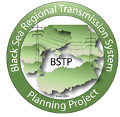

Energy Technology and Governance Program

BLACK SEA REGIONAL TRANSMISSION PLANNING PROJECT PSS/E NTC CALCULATION WORKSHOP/PREPARATION FOR JOINT BSTP/BSRI WORKSHOP

SUBAGREEMENT NO. USEA/USAID - 2017-708-01
March 20, 2017
Tbilisi, Georgia
Submitted by: Milos Stojkovic and Dragana Orlic, Electricity Coordinating Center (EKC)

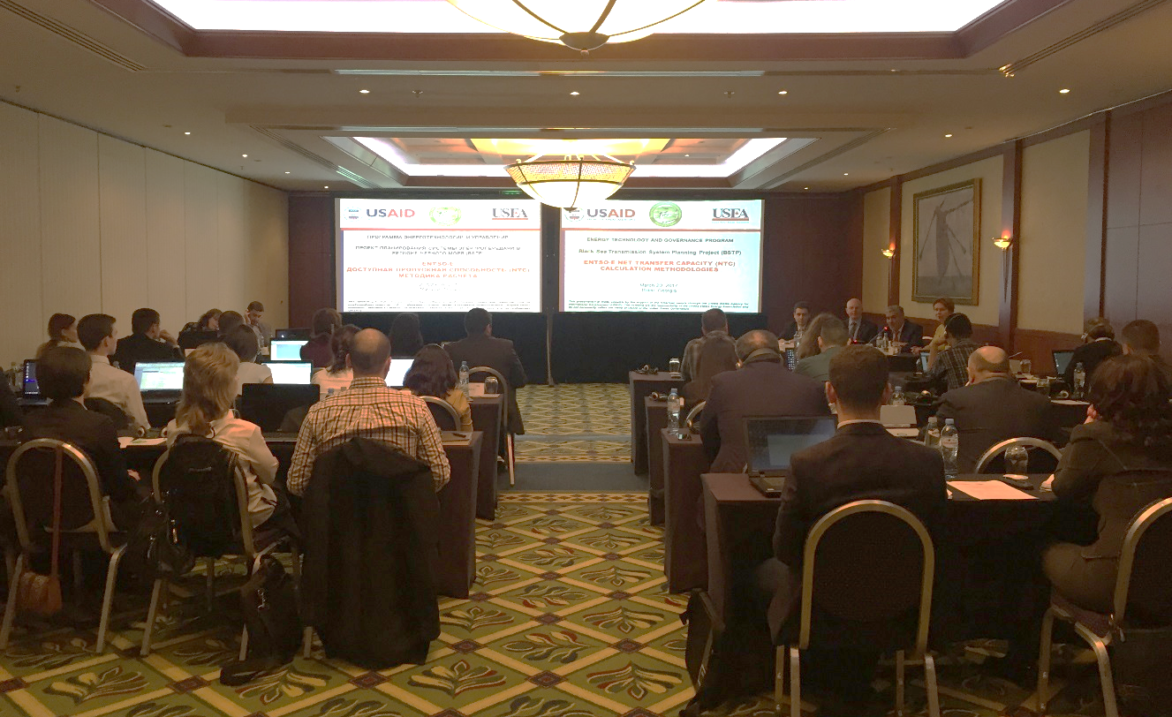
In cooperation with the United States Agency for International Development (USAID), the United States Energy Association (USEA) conducted one-day Working Group Workshop on PSS/E NTC Calculation in Tbilisi, Georgia on March 20, 2017. This workshop of the Black Sea Regional Transmission Planning (BSTP) Project as a part of Working Group project activities in 2017 is dedicated to the continuation of the building of institutional capacities within the BSTP TSOs along with the PSS/E HVDC Modeling Workshop which was held in follow. Aside with the recapitulation of previously acquired knowledge and insight into new developments in the field of transmission capacity calculation and allocation, one of the objectives was to prepare Working Group members for the joint BSTP/BSRI Workshop in June. June’s Workshop, among other things, should be used for the presentation of methodology for NTC calculations with explanations and practical calculation examples in BSTP region performed by BSTP TSO members.
The workshop was provided by Milos Stojkovic and Dragana Orlic, Electricity Coordination Center (EKC, Belgrade). The program was designed to improve the capacity of Working Group members to utilize ENTSO-E NTC calculation methodology which can be used to calculate the NTC values of current and prospective transmission networks.
NTC (Net Transfer Capacities) values change resulting from changes in network topology and number of PPs online, as well as addition of new lines or transformers and they should be recalculated periodically in order to give necessary information about available transfer capacities (ATC) of observed networks. Thus, the workshop should help participants in regular BSTP model updating (for planning horizon up to 2025) to ensure that programmed and analyzed power transfers are feasible and possible.
Besides, relatively wide format of the workshop which covered not only standard transfer capacity calculations (NTC/ATC methodology) but also some complex methods and additional options (Flow Based calculation methodology and implicit methods of capacity allocation) could be very helpful in regular, everyday work of participants in their companies.
The workshop has been focused on the following topics:
- Capacity Calculation
  - Definitions of transfer capacities (TTC, TRM, NTC, ATC)
  - NTC calculation procedures
  - Generation shift keys
  - Static security calculations and criteria
  - Dynamic security calculations and criteria
  - NTC calculation in case of HVDC interconnections
  - NTC results harmonization
- Capacity Allocation
  - Capacity allocation principles and methods
  - Market/non-market based
  - Explicit/implicit
  - Transaction-based methods (NTC/ATC based)
  - Flow-based methods
  - EU legislation regarding the Capacity Allocation
A total of 30 engineers participated in the workshop representing the TSOs of Armenia, Bulgaria, Georgia, Moldova, Romania, Turkey and Ukraine:
Armenia
- Garnik Balyan , Chief Engineer, System Operator JSC
- Gurgen Harutyunyan, Energy Institute of Armenia
- Karine Khachbulaghyan, Senior Specialist, System Operator JSC
- Hamlet Zakaryan, Engineer, System Operator JSC
- Gurgen Aghababyan, Engineer, System Operator, JSC

Bulgaria
- Diana Stefanova, Transmission Network Planning Engineer, ESO EAD
- Rosen Ulinski, Transmission Network Planning Engineer, ESO EAD

Georgia
- Vasil Enukidze, Engineer, System Stability and Analysis Section, GSE
- Tamar Jikia, Senior Engineer, Electrical Regimes Statistic Section, GSE
- Inna Osikmashvili, Engineer, Transmission Grid and Development Section, GSE
- Givi Shovnadze, Engineer, System Stability and Analysis Section, GSE
- Giorgi Vakhtangadze, Head, Transmission Grid Planning and Development Section, GSE
- Davit Datashvili, Engineer, System Automatic Section, GSE
- Jemal Akhalaia – Deputy Director, Energotrans
- Akaki Nemsadze, Engineer, Energotrans
- Irakli Tkeshelashvili, Engineer, Energotrans

Moldova
- Octavian Ciobirca, Engineer, Electrical Regimes Department, Moldelectrica
- Varvara Gulco, Senior Engineer, Electrical Regimes Department, Moldelectrica
- Dmitri Zastavnethni, Engineer, Electrical Regimes Department, Moldelectrica

Romania
- Anca Antemir, Head of Network Development Office, Transelectrica
- Oana Zachia, Head of Forecast Consumption Office, Transelectrica
- Alexandra Tolea, Transelectrica

Turkey
- Necip Fazil Bakir, Assistant Manager, Transmission Planning and Coordination Division, TEIAS
- Zafer Mertoglu, Engineer, Transmission Planning and Coordination Division, TEIAS

Ukraine
Western Power System, Lviv
- Taras Nakonechnyy, Deputy Chief, Regime Service, Central Dispatch Service
NPC Ukrenergo, Kiev
- Mykyta Vyshnevskyi, Deputy Head Electric Modes Optimization Service, Dispatch Department, NPC Ukrenergo
- Alla Umanets , Senior Regime Calculation Specialist, Prospective Development Department
- Tetiana Tkachuk, Electrical Regimes Optimization Division
- Irina Stasyuk, Regime Calculation Specialist, Prospective Development Department
- Kostiantyn Lytvynenko, Regime Calculation Specialist, Prospective Development Department

During the workshop, the Working Group members were accustomed with the standard transfer capacity calculations based on ENTSO-E NTC calculation methodology which can be performed by the PSS/E Load Flow and Contingency Analysis module. Through hands-on exercises participants gained practical experience in NTC calculations, modeling and preparation of reports, setting and managing input data and interpreting results.
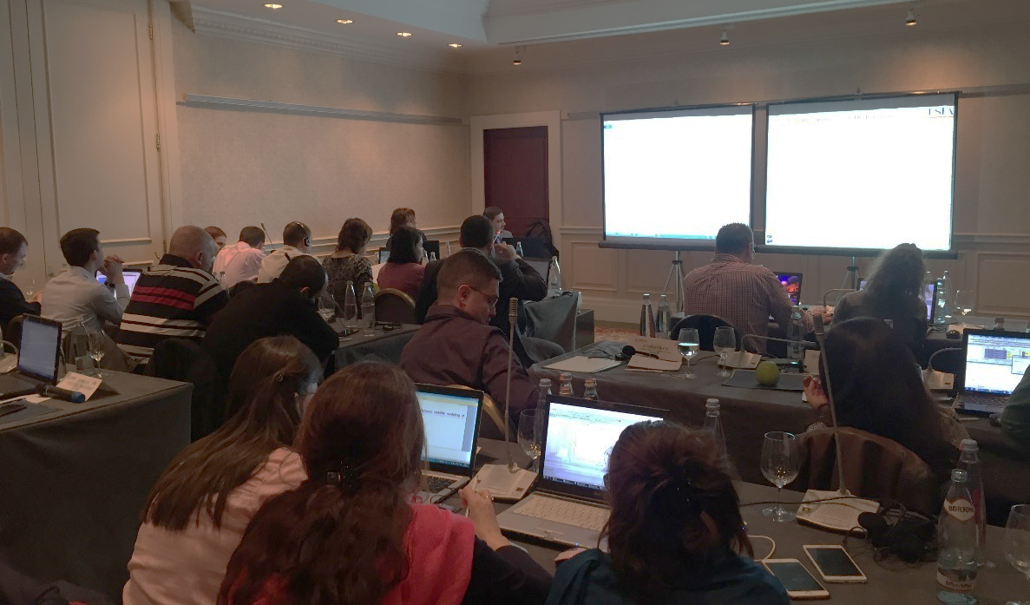
The workshop began with a general overview and main definitions in order to introduce participants with usual standard terminology and physical explanation of process. Concept of capacity calculation and allocation was explained taking into account contemporary experience and ENTSO-E practice.
First session of capacity calculation part was dedicated to the methodology aspects and definitions of transfer capacities variables:
- Base Case Exchange (BCE)
- Additional exchange (ΔEmax)
- Total Transfer Capacity (TTC)
- Transmission Reliability Margin (TRM)
- Net Transfer Capacity (NTC)
- Already Allocated Capacity (AAC)
- Available Transmission Capacity (ATC)
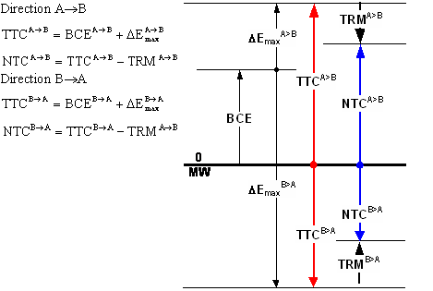
There was explained also a concept of loop flows and difference between program and physical flows in meshed systems.
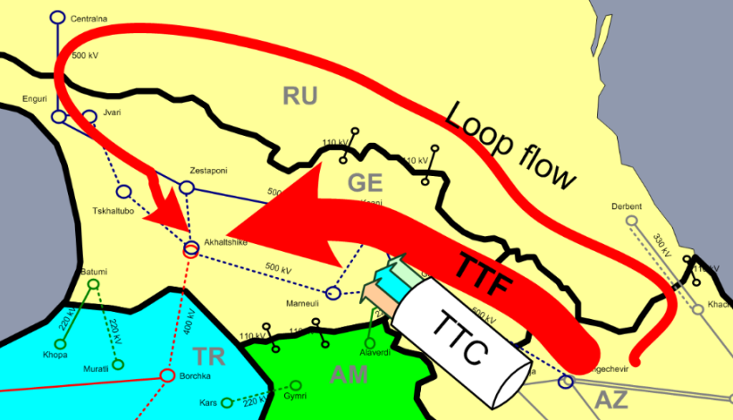
Further, NTC calculation procedure was explained taking into account different types of analysis for observed or transit power systems (bilateral vs composite NTCs) as well as the application of different methods for generation shift keys. Working Group members showed particular interest in the last category related to the practical usage of different generation shift key concepts for NTC calculations. There were several questions about these issues mainly from TSO representatives which recently started with the process of standard NTC calculations (in particular in case of Georgia and Ukraine).
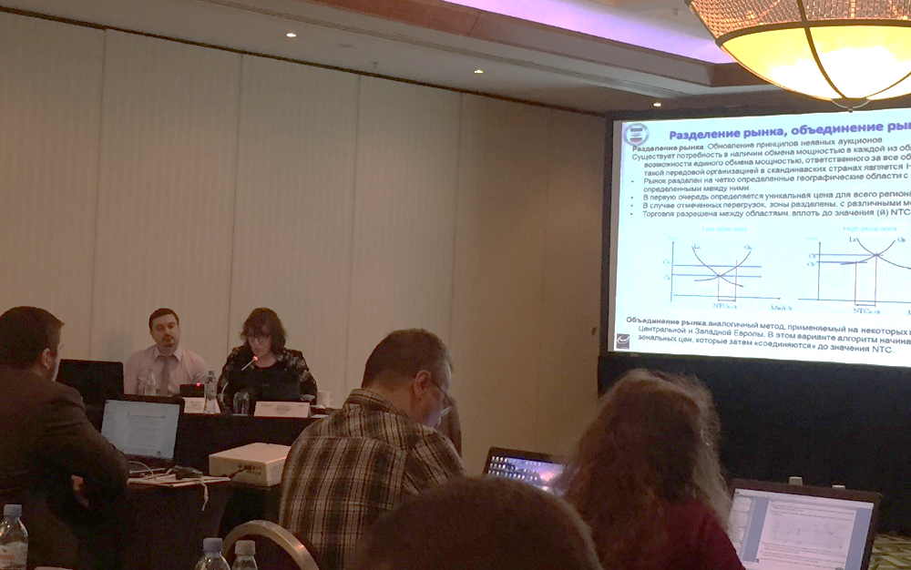
Working Group members’ questions were dedicated mainly to the treatment of TRM (Transmission Reliability Margin) in different situations. Colleagues from Georgian TSO discussed concept and meaning of internal congestion and usage of appropriate TRM values for different internal issues.

Next part of the workshop covered cross-border capacity allocation principles and methods. Non-market based methods (capacity reservation, priority list and pro-rata rationing) and both, explicit and implicit auctions as market based methods were discussed.
Explicit Auctions
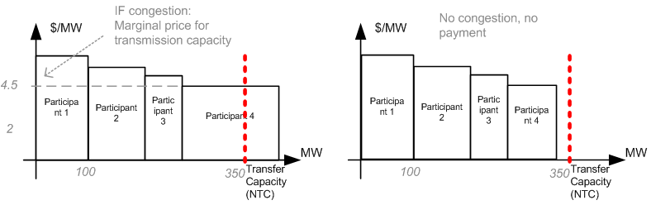
Implicit Auctions
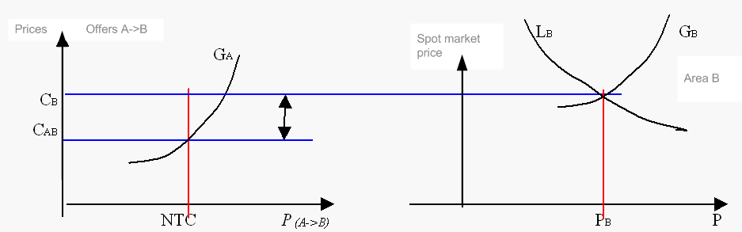

Technical aspects of capacity allocation were discussed taking into account not only Transaction Based (NTC/ATC) methods, but Flow Based method, as well. This is more complex coordinated method for highly meshed systems based on physical flows (PTDF/Maxflow).
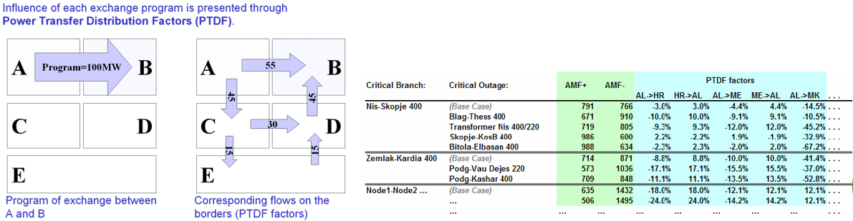
Basic principles of Flow Based method and PTDF matrix calculation, as well as the difference between NTC/ATC and Flow-based methods were explained.
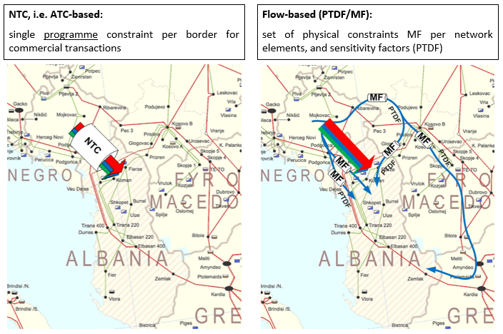
Further, historical development of EU legislation regarding the capacity allocation was presented as well as the current status of the NTC/ATC and Flow-based in Europe.
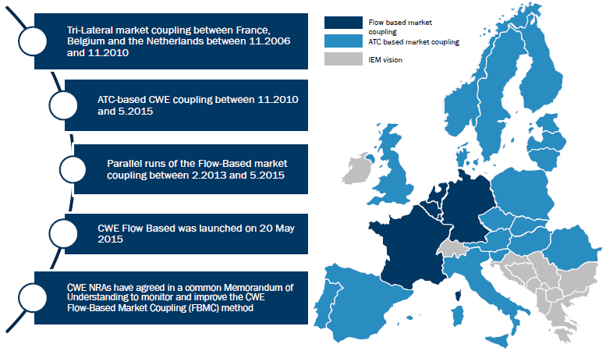

Last section considered practical example which showed the implementation of ENTSO-E NTC calculation methodology within PSS/E software environment. Procedures, input data, auxiliary files, simulation options and calculation parameters were explained as well as ways of how to show calculation results in form of some standard report which should cover all methodology aspects.

NTC Calculation Procedure:
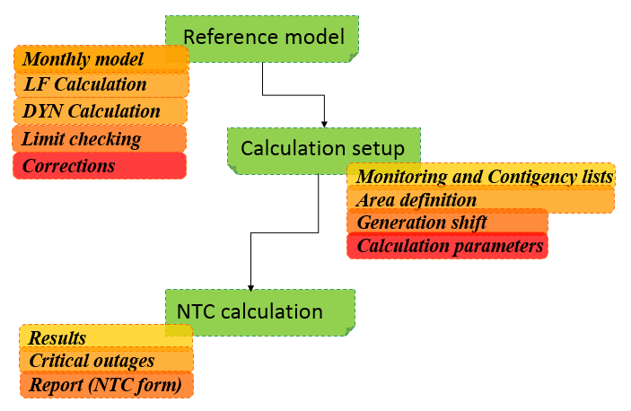
Monitoring and contingency lists/area definition:
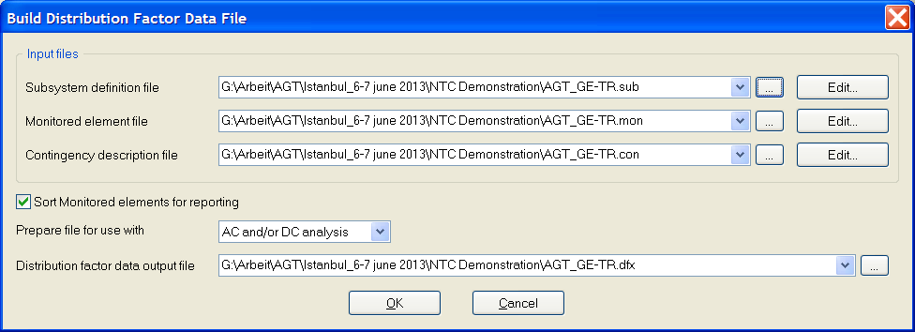
Generation shift procedure as semi-automatic via SCAL function (option proportionally to base case generation):
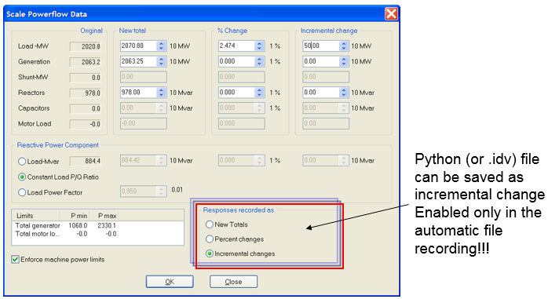
Setting the additional exchange between the areas:
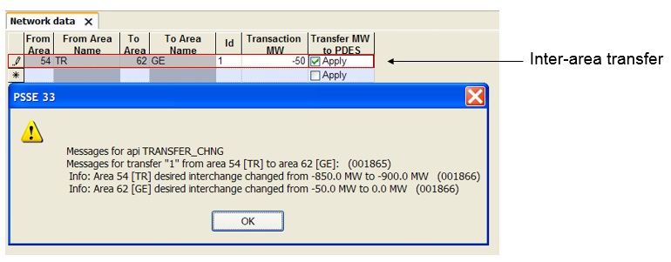
NTC results, critical outages (AC Contingency solution and AC Contingency Report):
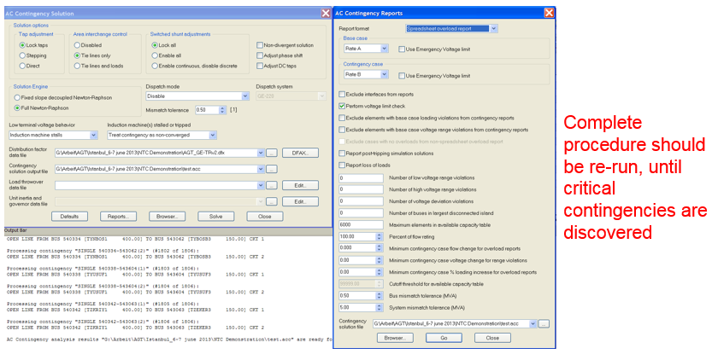
NTC results harmonization – final table:
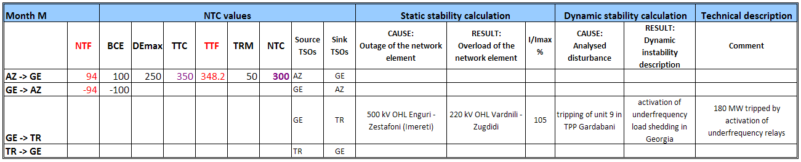

In the end, in order to recapitulate NTC calculation knowledge as well as to prepare themselves for the joint BSTP/BSRI Workshop in June, some transfer capacity analysis were proposed to be carried out by BSTP members. This includes circular cross-border capacity calculations for own and one neighboring power system by using actual 2020 BSTP model (both, winter maximum and summer minimum regimes) which would be temporary upgraded and adjusted only in case of Romania – Moldova border by adding missing link for this exercise purposes (This link is normally envisaged for the period after 2020).
EKC will provide all necessary support from choosing of target contingency and monitoring power system elements, through the calculation process until the finalization of necessary (short) reports in presentation form. Time frame for model testing would be from the beginning of April until the mid of May.
Homework Scenarios:
BSTP Member | Border | Regime | Direction
Armenia | AM-GE | 2020 year  Winter Maximum  Summer Minimum | Both
Bulgaria | BG-RO
Georgia | GE-TR
Moldova | MD-UA
Romania | RO-MD
Turkey | TR-BG
Ukraine | UA-RO

The template for the presentation on NTC results was discussed and it was agreed that report should contain the following:
- Introduction
- NTC Calculation Prerequisites:
  - Base Case Exchange (BCE) and Notified Transmission Flows (NTF)
  - Transmission Reliability Margin (TRM)
  - Already Allocated Capacity (AAC)
  - Generation Shift Keys (GSK)
- NTC Calculation Procedure:
  - Algorithm
  - Creation of Auxiliary Files for Calculation (MON, CON, SUB)
  - Static and Dynamic Security Calculations
- NTC Calculation Results
- Conclusions

After the homework explanations, current status of collected input data for the Study – Analysis of the Potential to Provide Cross-border Balancing Reserves and Energy in the Black Sea Region has been discussed. The results are summarized in the table below:
Status of the data collection process (TSO questionnaires for BSTP 2017):
BSTP Member | Status
Armenia | Questionnaires are partially ready. They asked for the confirmation if generation refers to year 2020. It is expected that tables will be filled within next 2 weeks.
Bulgaria | Questionnaires are distributed to relevant department(s) and process of data collection is on-going. It is expected that tables will be filled within next 2 weeks.
Georgia | No info since the head of department was absent during the interview.
Moldova | Questionnaires are reviewed and process of data collection is on-going. They had some questions which we discussed about during this mission. They are not sure about the time when data can be finalized.
Romania | Questionnaires are 80% ready. It is expected that tables will be filled within next 2 weeks.
Ukraine | Questionnaires are distributed between transmission and market departments. Some of the data are already collected and sent. In next 10 days they expect to finish.
Turkey | Questionnaires are distributed to relevant department(s) and process of data collection is on-going. It is expected that tables will be filled within next 2 weeks.

The workshop was held in good atmosphere among presenters and participants. Since the workshop was interactive, a lot of questions and requests for further explanations have been raised. Most of these questions were related to practical issues and experience from their national systems, in particular regarding NTC calculation results concerning TRM values and internal congestion problems.
All participants were satisfied with quality of the workshop and expressed ideas for further workshops, but no concrete ideas were discussed.
Participants were awarded Certificates of Achievement signed by USAID and USEA upon completion of the PSS/E HVDC Modeling Workshop.

