Principal Recommendations
The most impactful action the U.S. can employ to reduce CO₂ emissions is to incentivize the rapid deployment of carbon capture utilization and storage (CCUS) technologies.

- Build on the Consensus. Efforts should be undertaken to build on the expanding consensus among industry, the environmental community and governments that future CO₂ reduction goals cannot be met by renewable energy sources alone. An expanded coalition of fossil fuel users and producers should collaborate to help develop and commercially deploy CCUS technologies on an accelerated time schedule with the aim of achieving global climate objectives and insuring a reliable grid.

- Prioritize CO₂ Utilization Technology Deployment. Geological CO₂ utilization options, including but not limited to CO₂ for enhanced oil recovery (CO₂-EOR), have the greatest potential to advance CCUS by creating market demand for anthropogenic CO₂. Monetary, regulatory and policy investments in CO₂ utilization technologies should be roughly prioritized from geologic to non-geologic, with exceptions made if non-geologic technologies are found to be as effective as geologic storage.

- Pursue Non-Geologic CO₂ Markets as Longer Term Opportunities. Non-geologic CO₂ utilization options are unlikely to significantly incentivize CCUS in the near- to intermediate-term due to technical, greenhouse gas (GHG) lifecycle considerations and lack of scalability. However, a broadly deployed mix of CO₂ utilization technologies may help to advance CCUS incrementally, providing sufficient incentive to keep CCUS technologies moving forward. Non-geologic technologies that can “fix” CO₂ molecules intact, akin to geologic storage, hold the most promise and are worthy of continuing RD&D, including inorganic carbonates/bicarbonates, plastics/polymers, organic/specialty chemicals and agricultural fertilizers.

- Pursue Impactful Options to Facilitate Regulatory Compliance. U.S. and international GHG reduction objectives and timeframes dictate the need to employ CO₂ utilization technologies that can be quickly commercialized at significant scale. U.S. law recognizes CO₂-EOR and other geologic technologies as compliance options; non-geologic technologies may be used only if EPA determines they are as effective as geologic storage. NCC recommends applying a reasonable market potential threshold of 35 MTPY, which is roughly equivalent to the annual CO₂ emissions from about 6 GWe or a dozen 500 MWe coal-based power plants.

- Establish a Technology Review Process. There is benefit to establishing a technology review process that is as objective as possible to assess the benefits and challenges of different CO₂ utilization technologies and products. Evaluation criteria fall into three broad categories: 1) environmental considerations, 2) technology/product status and 3) market considerations. Evaluation criteria can be used to prioritize candidates for RD&D and product investment.

http://www.nationalcoalcouncil.org/studies/2016/NCC-CO2-Building-Block-FINAL-Report.pdf
http://www.nationalcoalcouncil.org/page-NCC-Studies.html

“I am writing to request the National Coal Council (NCC) develop an expanded white paper assessing opportunities to advance commercial markets for carbon dioxide (CO₂) from coal-based power generation. What is the extent to which commercial EOR and non-EOR CO₂ markets could incentivize deployment of Carbon Capture and Storage (CCS)/Carbon Capture, Utilization and Storage (CCUS) technologies? What economic opportunity does deployment of commercial-scale CCS/CCUS technology represent for the U.S.?”
U.S. Secretary Ernest J. Moniz – February 2016

The National Coal Council’s “CO₂ Building Blocks” report acknowledges the growing consensus among industry, the environmental community and governments that future CO₂ emission reduction goals cannot be met by renewable energy sources alone and that CCUS technologies for all fossil fuels will have to be deployed in the near term to achieve U.S. and global climate objectives.
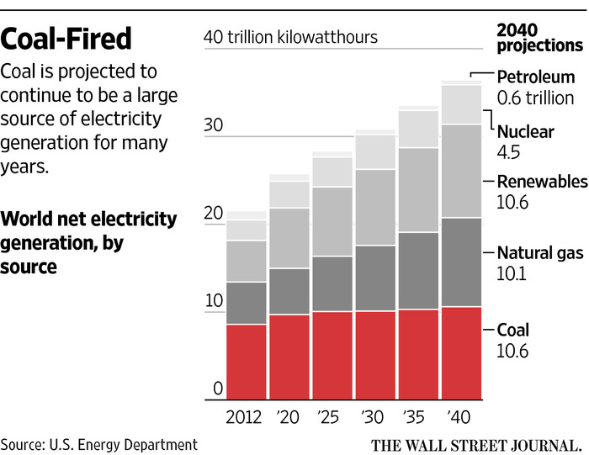
* Fossil fuels – including coal, natural gas and oil – will remain the dominant global energy source well into the future by virtue of their abundance, supply security and affordability.

* Advancing CCUS is not just about coal, nor is it just about fossil fuels generally. Rather, it is a sine qua non for achieving stabilization of GHG concentrations.

* CO2 for enhanced oil recovery (CO₂-EOR) represents the most immediate, highest value opportunity to utilize the greatest volume of anthropogenic CO₂, thereby incentivizing CCUS.

* Aside from CO₂-EOR and other geologic CO₂ utilization options – including CO₂ in natural gas shale formations, enhanced coal bed methane (ECBM), enhanced water recovery (EWR) and geothermal energy storage – research is underway on two general utilization pathways. The first breaks down the CO₂ molecule by cleaving C=O bonds while the second incorporates the entire CO₂ molecule into other chemical structures. The latter holds relatively more promise as it requires less energy and tends to “fix” the CO₂ in a manner akin to geologic storage.

*Utilizing CO₂ in non-geologic applications faces hurdles, including yet-to-be resolved issues associated with thermodynamics and kinetics involved in the successful reduction of CO₂ to carbon products. Still these technologies are worthy of continuing evaluation and many hold long-term potential in specific applications.

* An objective technology review process that assesses the challenges and benefits of different CO₂ utilization technologies and products could be used to prioritize candidates for RD&D and product investment.

* Current U.S. policy favors geologic-based utilization pathways for Clean Air Act compliance. U.S. law recognizes CO₂-EOR and other geologic storage technologies as compliance options; non-geologic technologies may be used only if EPA determines they are as effective as geologic storage.
CO₂ Emissions – BP Energy Outlook 2016
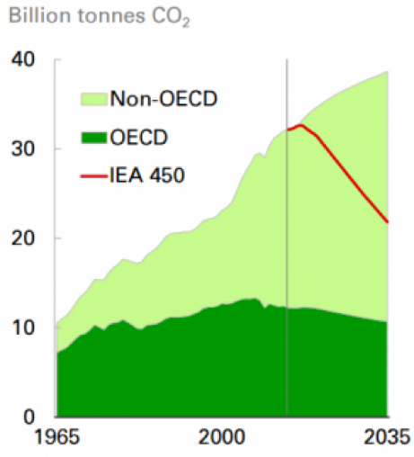
The BP Energy Outlook 2016 notes that the level of CO2 emissions is expected to continue to grow, increasing by 20% between 2014 and 2035. The gap between the projected path for CO₂ emissions and the International Energy Agency’s (IEA) 450 Scenario demonstrates the challenge associated with reducing GHG emissions.

Both the IEA and the United Nation’s Intergovernmental Panel on Climate Change (IPCC) have concluded that CCUS is essential to limit global warming to 2⁰C. IEA estimates that CCUS can achieve 14% of the global GHG emissions reductions by 2050.

Fossil fuels generally and coal specifically are dependent upon CCUS technologies to comply with U.S. GHG emissions reduction requirements. U.S. law requires new major stationary sources and major modifications to existing sources of GHG to reduce their emissions with geologic storage options – specifically including CO₂-EOR – as preferred mitigation technologies. These U.S. legal requirements are reinforced by the 2015 Paris Agreement which largely envisions the decarbonization of major energy systems through the use of CCUS and other technologies by 2050.

CO₂-EOR still represents the most immediate, highest value opportunity to utilize the greatest volumes of anthropogenic CO₂.

Technically Recoverable Domestic Oil and CO₂ Storage Capacity, State of the Art and “Next Generation” CO2-EOR Technology
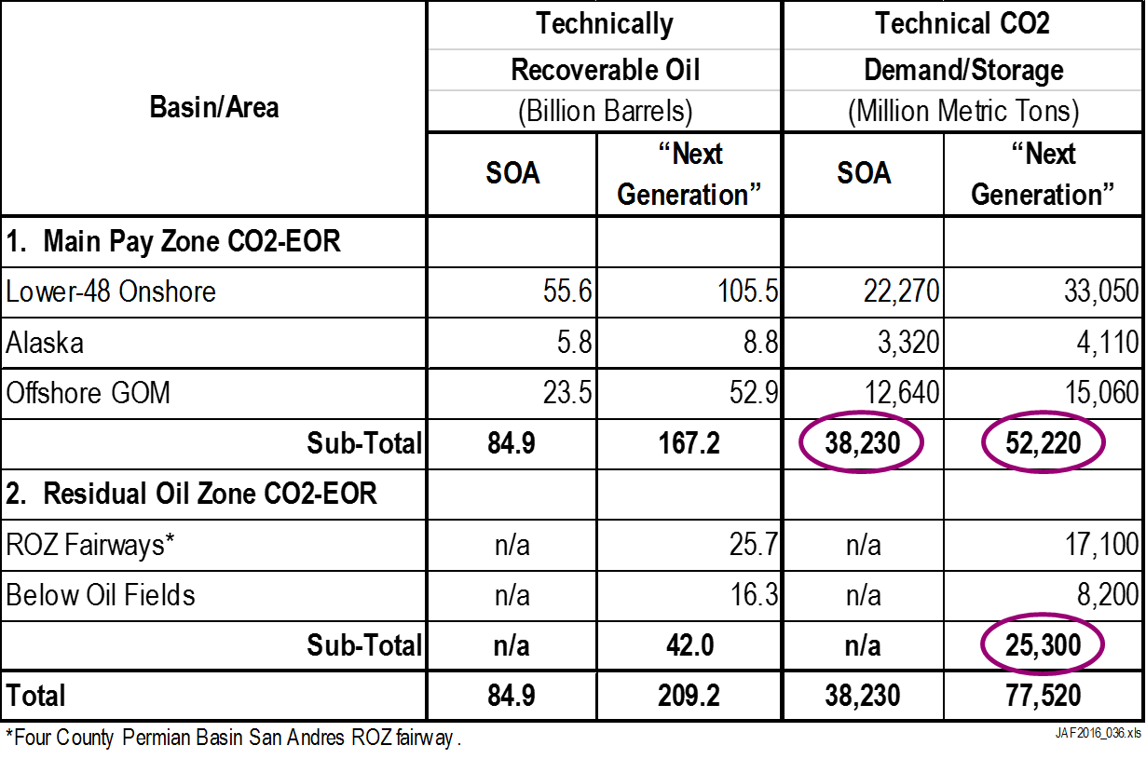
With a potential for 81 billion barrels of economically viable oil recovery from mature oil field and residual oil zones (assuming the use of “Next Generation” technology), the various CO₂-EO stakeholders would gain valuable revenue and economic benefits.

 | Recipients of CO₂-EOR Revenues* | Revenues
• | CO₂ Capture and Transporters | $1,210 billion
• | State, Local and Federal Treasuries | $1,130 billion
• | CO₂-EOR Investors (including Return on Capital) | $1,270 billion
• | General Economy/Mineral Owners | $2,060 billion
 | Total | $5,670 billion
*Assuming an oil price of $70/B.

Other geologic options include utilization of CO2 in natural gas shale formations, for production of enhanced coal bed methane (ECBM), for enhanced water recovery (EWR) and for enhanced geothermal energy and subsurface energy storage.

Non-geologic CO₂ utilization options may hold long term potential but are unlikely to significantly incentivize CCUS in the near- to intermediate-term because of technical challenges, GHG lifecycle considerations and issues associated with scalability.
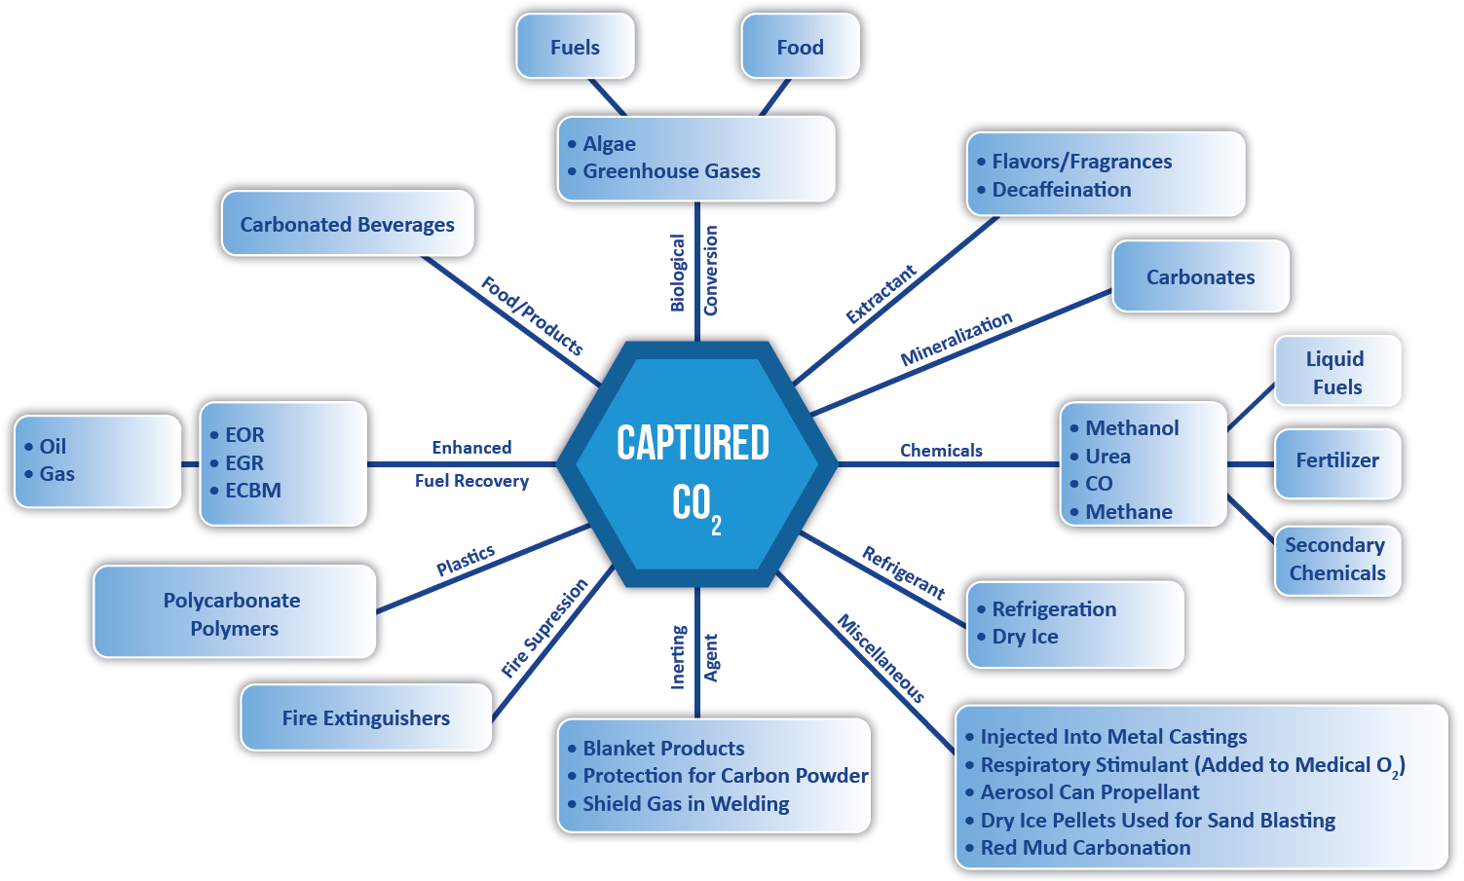
Some non-geologic utilization opportunities are promising incentives for CCUS in that they tend to “fix” CO2 so have the advantage of potentially serving as preferred carbon management solutions. These include (1) inorganic carbonates and bicarbonates; (2) plastics and polymers; (3) organic and specialty chemicals; and (4) agricultural fertilizers.
CO₂ may also be utilized through chemical and biological processes to produce transportation fuels, which is a very large market. This pathway is unlikely to incentivize CCUS in the immediate future because 1) these fuels are ultimately combusted and thus release CO₂ to the atmosphere and 2) current U.S. policy favors geologic-based utilization pathways for CAA compliance. And while the case could be made that some CO₂-derived transportation fuels have lower GHG emissions than fossil-based fuels on a GHG LCA basis, non-fossil-based transportation fuels still face significant market competition and displacement hurdles.
The CO₂ molecule is particularly stable and has a Gibbs energy of formation of -394.4 kJ/mol – which must be overcome.
Thus, breaking the C=O bond(s) and forming C-H or C-C bond(s), or producing elemental carbon, is possible. However, such molecules are at a much higher energy state, meaning that a tremendous amount of energy must be used. Converting CO₂ to fuels or other high energy state molecules requires more energy input than could ever be derived from the end products.
CO₂ can also be incorporated into various chemicals as a C₁ building block. This is not thermodynamically challenged because the entirety of the CO₂ molecule is used and thus the C=O bonds are not broken. For this application, the principal challenge is the scale of available reactants and market for products, both of which are dwarfed by global CO₂ emissions.
Thermodynamics & kinetics of CO₂
It can be challenging to compare CO₂ utilization technologies because they face different growth and economic challenges. For example, some are more mature than others; some require infrastructure while others require RD&D; and some create large potential demand for CO₂ while others are more modest. The development of an objective technology/product review process can help to identify technology strengths and weaknesses, therefore contributing to a more robust technology development and investment strategy. Important factors for consideration should include:

* Environmental Considerations
For example, what is the security, reliability and longevity of associated CO₂ storage or reductions?
* Technology/Product Status
For example, is the technology at or near commercial status?
* Market Considerations
For example, is the potential market for CO₂ on a scale commensurate with coal-based power plants or other alternative uses of coal?

National Coal Council
www.NationalCoalCouncil.org
202-756-4524 ~ info@NCC1.org

